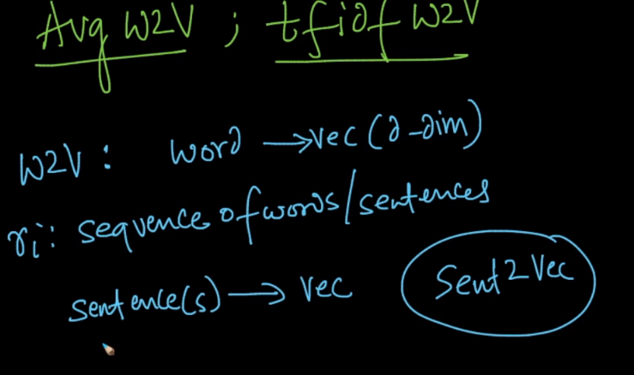

By finding average of w2v we can get sentence2vec as.

For any sentence find w2v of all words then divide them by number of words in that sentence, and this is avg w2v

Let say for n reviews, there are d unique words, and each word is having m dimensions. The dimensions of a word2vec vector depends on the size of the vector you choose while training the word2vec model(In case of both skip gram and CBOW you use a shallow neural network to train the model). So in the end the sentence vector will be of size m(same as the word vector as a sentence vector is just an average of all the word vectors). The final size would be nxm.

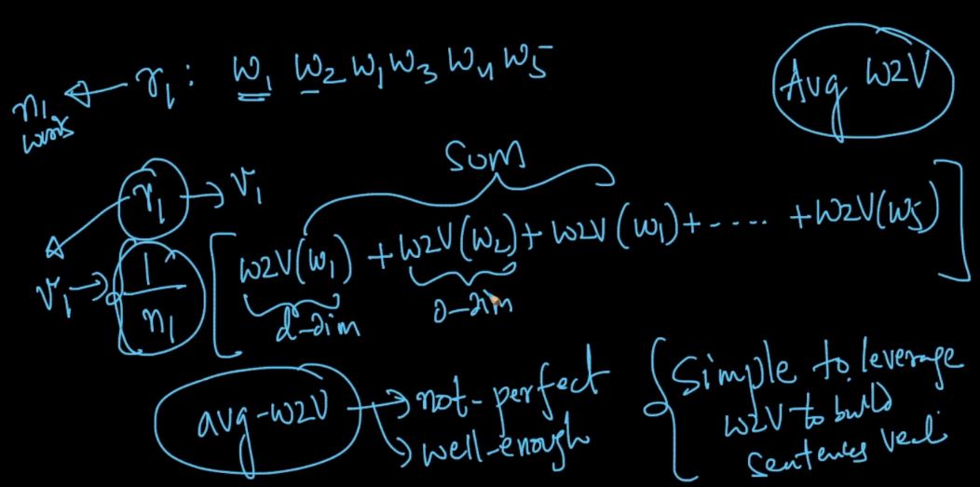

**TF-IDF weighted w2v**:

For any sentence we will multiply the tf-idf of each word with w2v of that word, and then take sum for all the words.

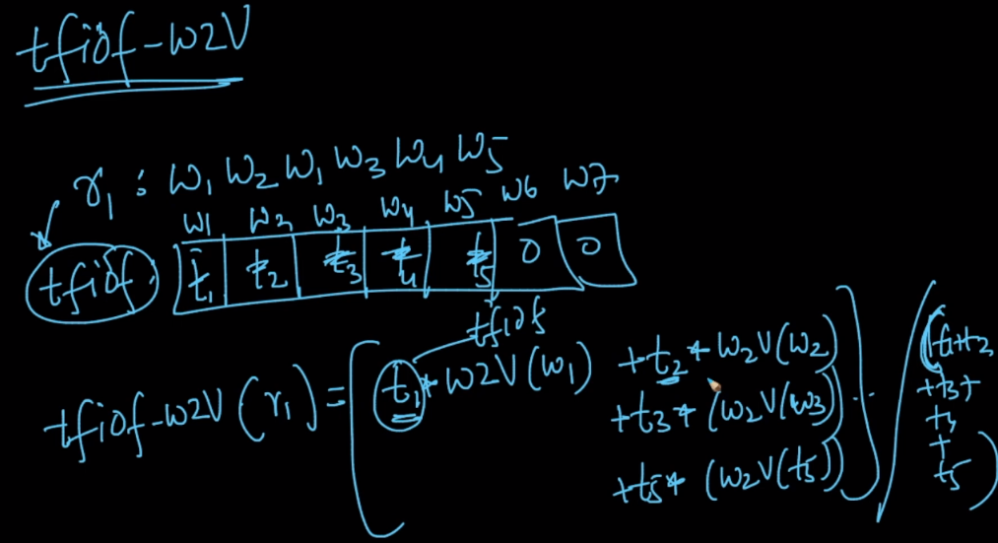

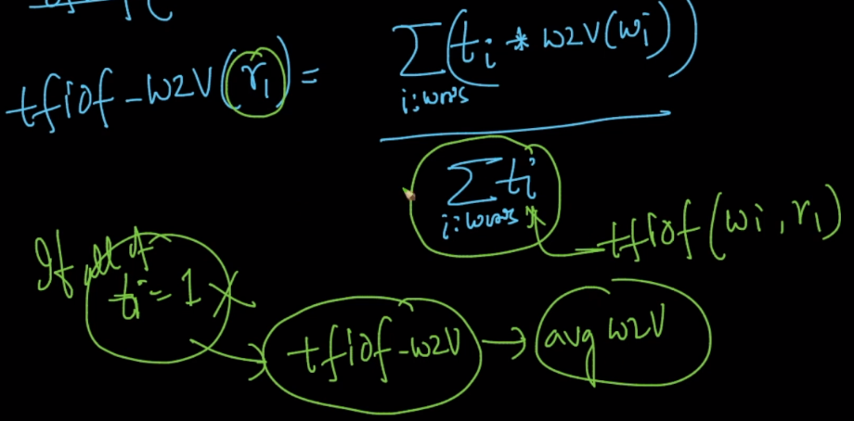

If all ti becomes 1 then tf-idf weighted w3v becomes average w2v, but we not always get ti = 1.

